# Introduction

This document describes the Archie Eclipse Plug-in that was developed at the **Software and Requirements Engineering Center** at **DePaul University**. The plug-in helps java developers using the **Eclipse IDE** analyze their source code, visualize and detect their security-related architectural decisions, recognize similarity between source files, and monitor any changes made to source files that may affect some decisions they made.

# How to Package the Plug-in

Do the following.

* Create a new Eclipse project. Select under Plug-in Development, Feature Project. Press Next.

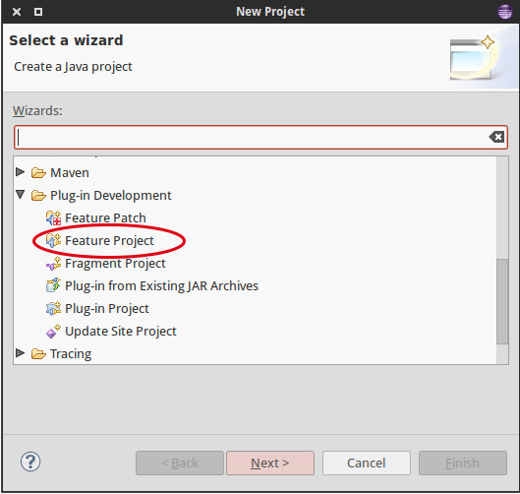

* Fill in the next window with the appropriate values. See an example below.

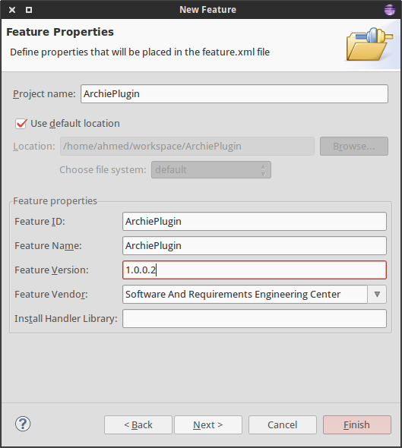

* In the next window, select from the list the ID of the Archie plug-in development project (the project that actually contains the source code). Click "Finish".

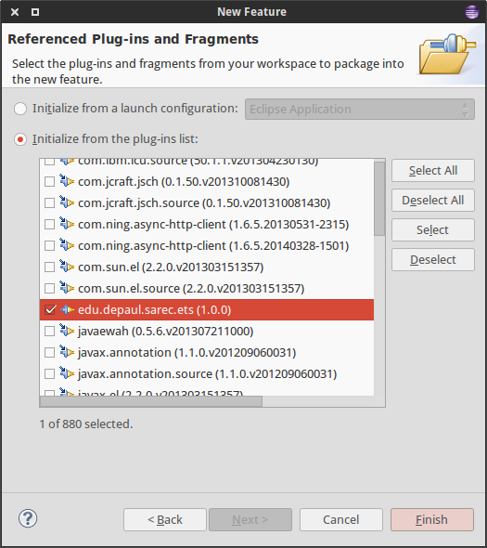

* Open the "feature.xml" file if it's not already open. Fill the data as desired. Fill the "Branding Plug-in" field by clicking on browse and looking up the plug-in ID from the list.

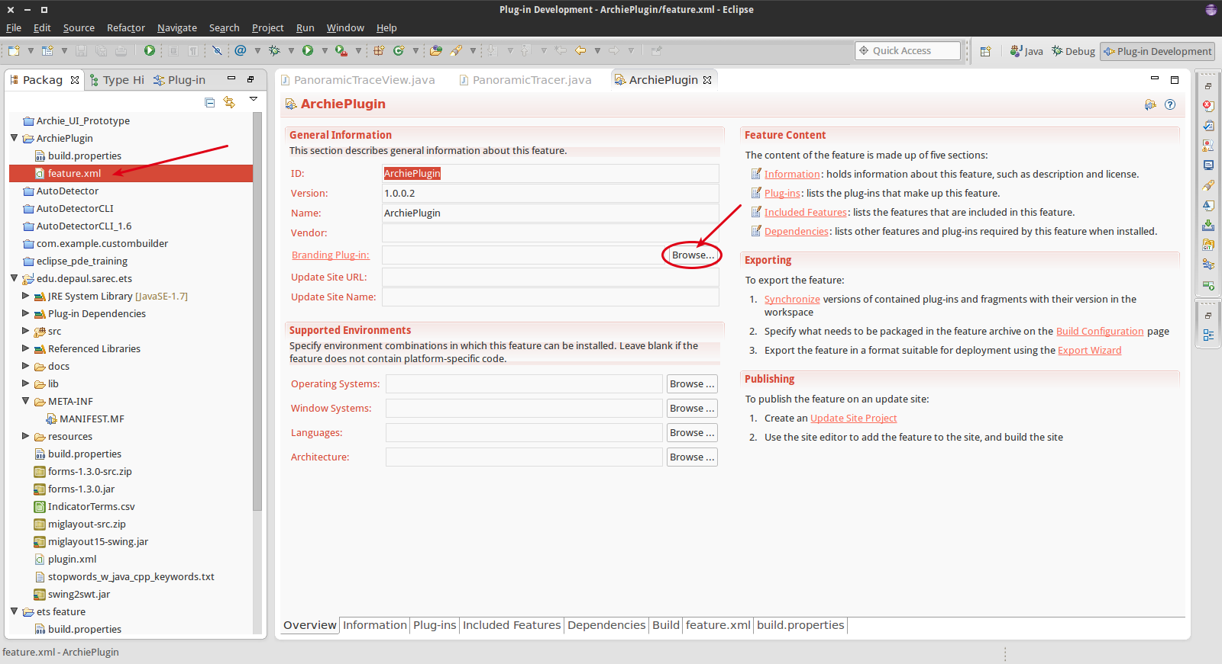

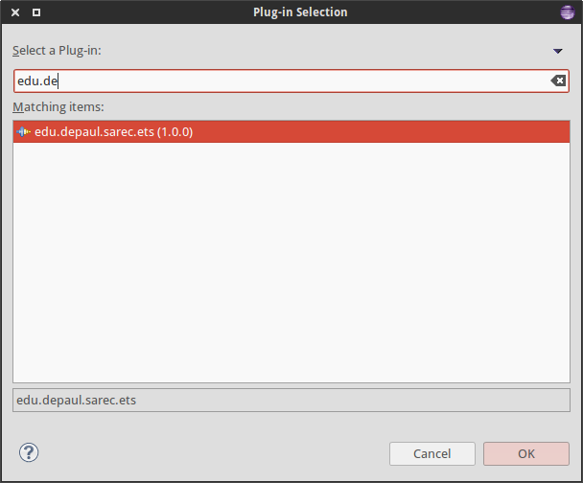

* Add a new file to the feature project by right clicking the project name, New > Other … > Plug-in Development > Category Definition. Click "Next". Name the file whatever you want, and click "Finish".

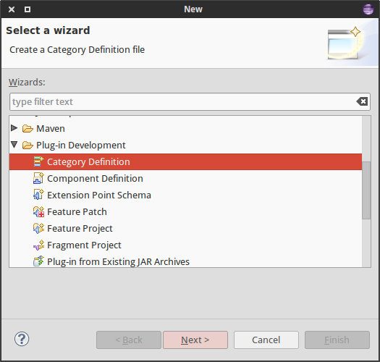

* Open the xml file of the category you just created, if it's not already open. Click "New Category" and give the newly created category an ID and a name, as shown in the below example.

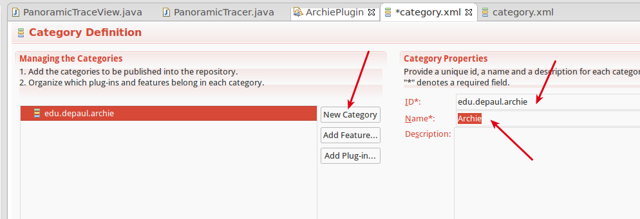

* Now click "New Feature" and choose the name of the feature that you just created.

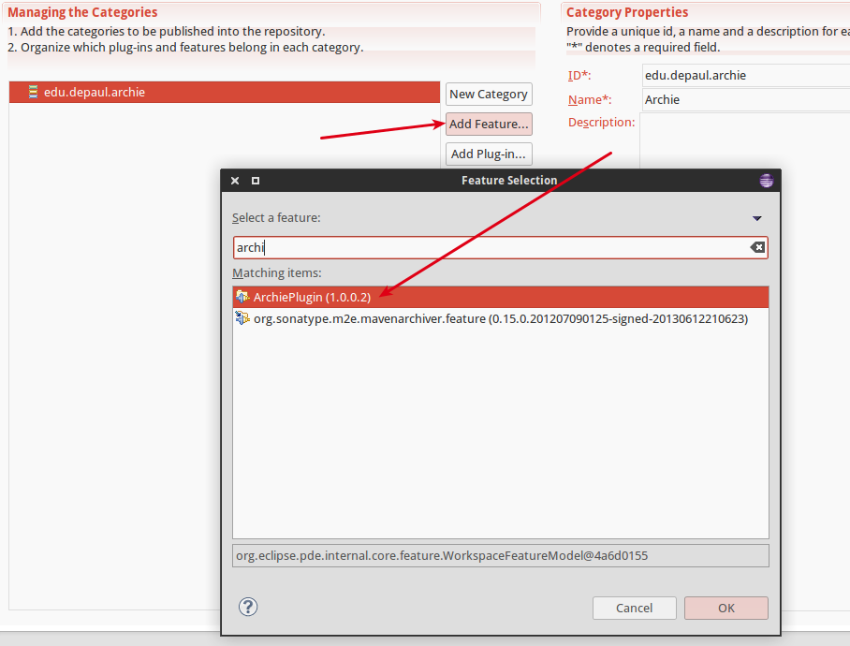

* Now add a plug-in by clicking the "Add Plug-in..." button. This time select the ID of the archie plugin.

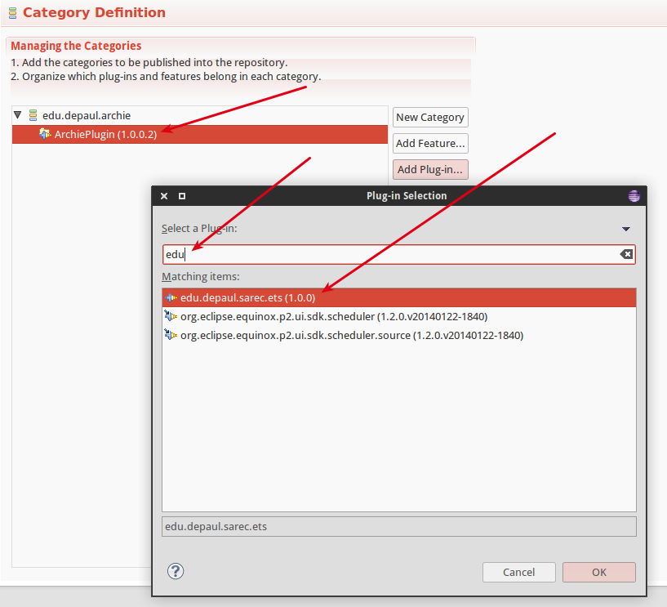

* Don't forget to save these files after you make any changes.
* Go back to the feature xml file and make sure that the category file that you just added is included in the build.

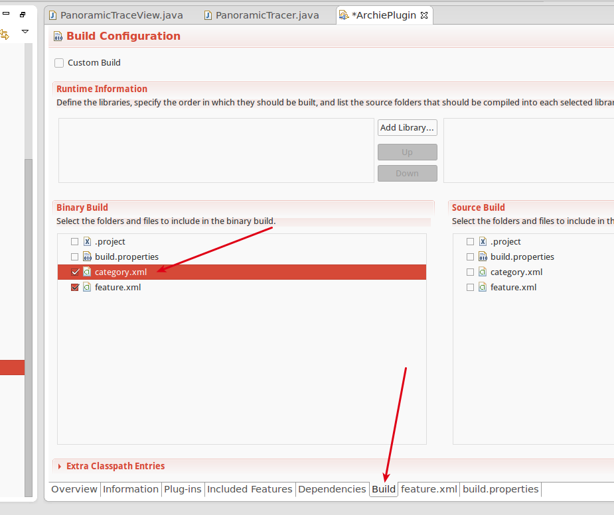

* Click the "Export to a deployable feature" button, and select from the window the feature you just created, and the location where you want to export the package.

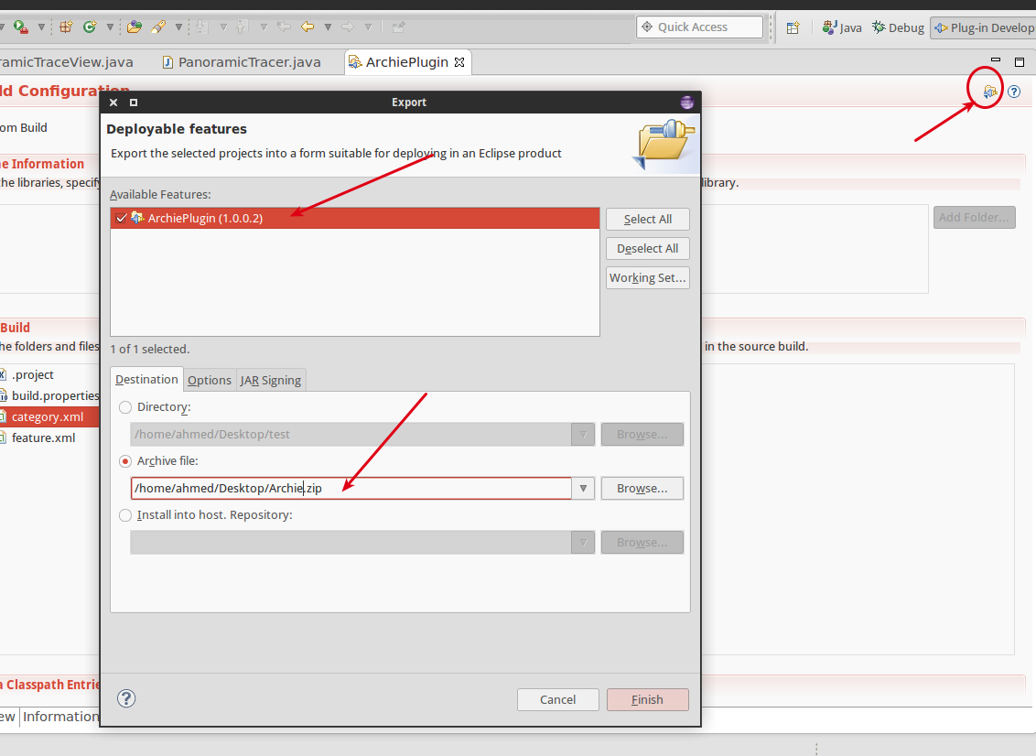

* From the "Options" tab in the same window, Make sure you are using the category file you created earlier to categorize the plug-in.

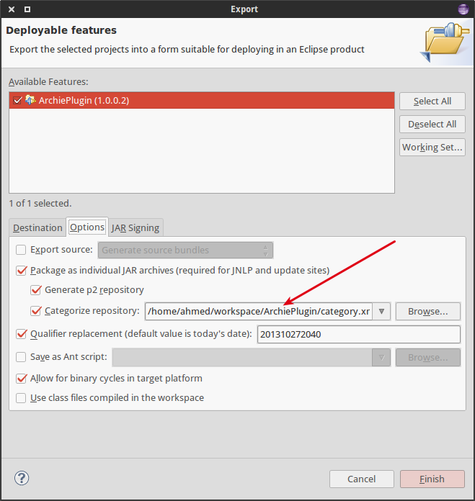

* Click "Finish". The plug-in should start exporting.
* The exported feature can be installed on any eclipse. Select Help > Install New Software … Then from the opened window, click on the "Add..." button, Then use the "Archive" button to navigate to the location of the exported feature.

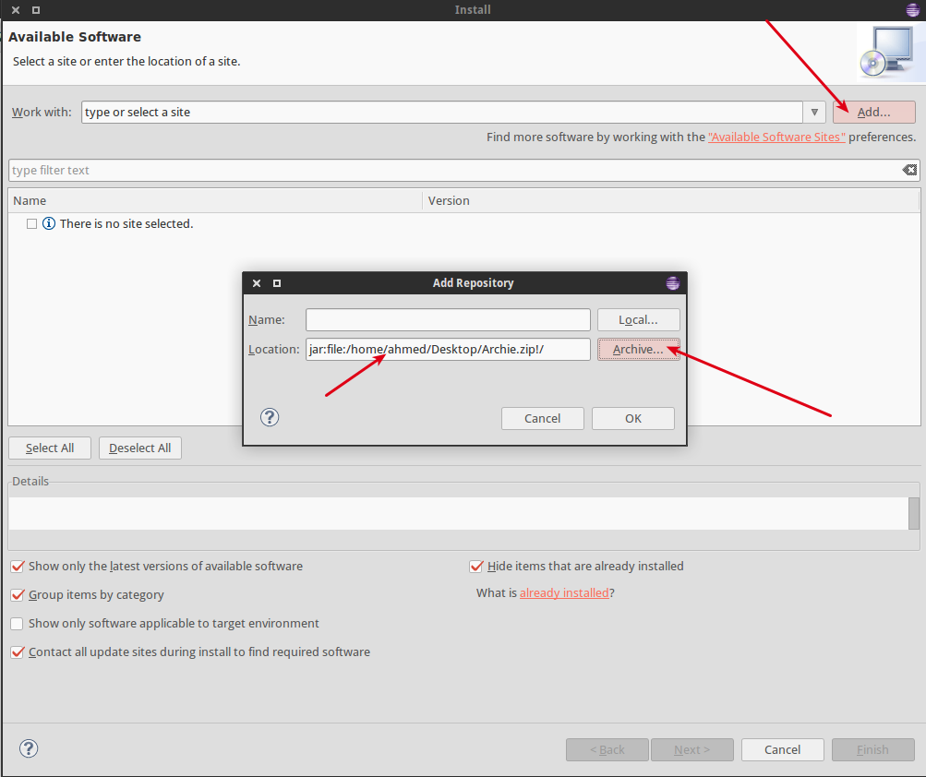

* Now the plug-in can be installed normally.

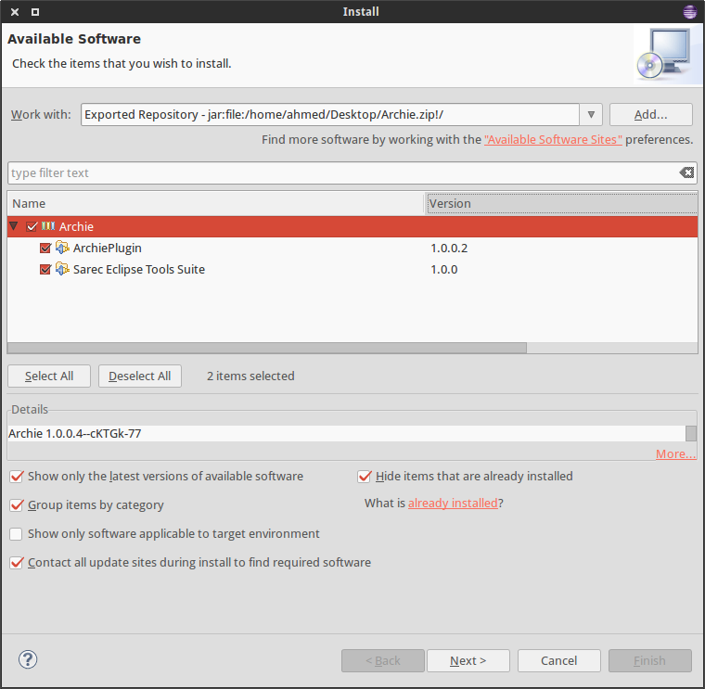

# How to Add More Indicator Terms

In the plug-in source files, there's a folder named **"resources/engine/"**, there you'll find a **CSV** file that contains the list of indicator terms that the plug-in uses internally.

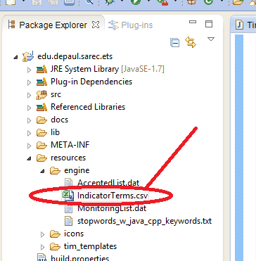

You can add more terms to this file and they will be recognized by the plug-in. The format of each entry is:

|  |
| --- |
| Quality Type, Term, Probability |

Where is **Quality Type** the name of the tactic, the **Term** is the indicator term, and the **probability** is the term's score.